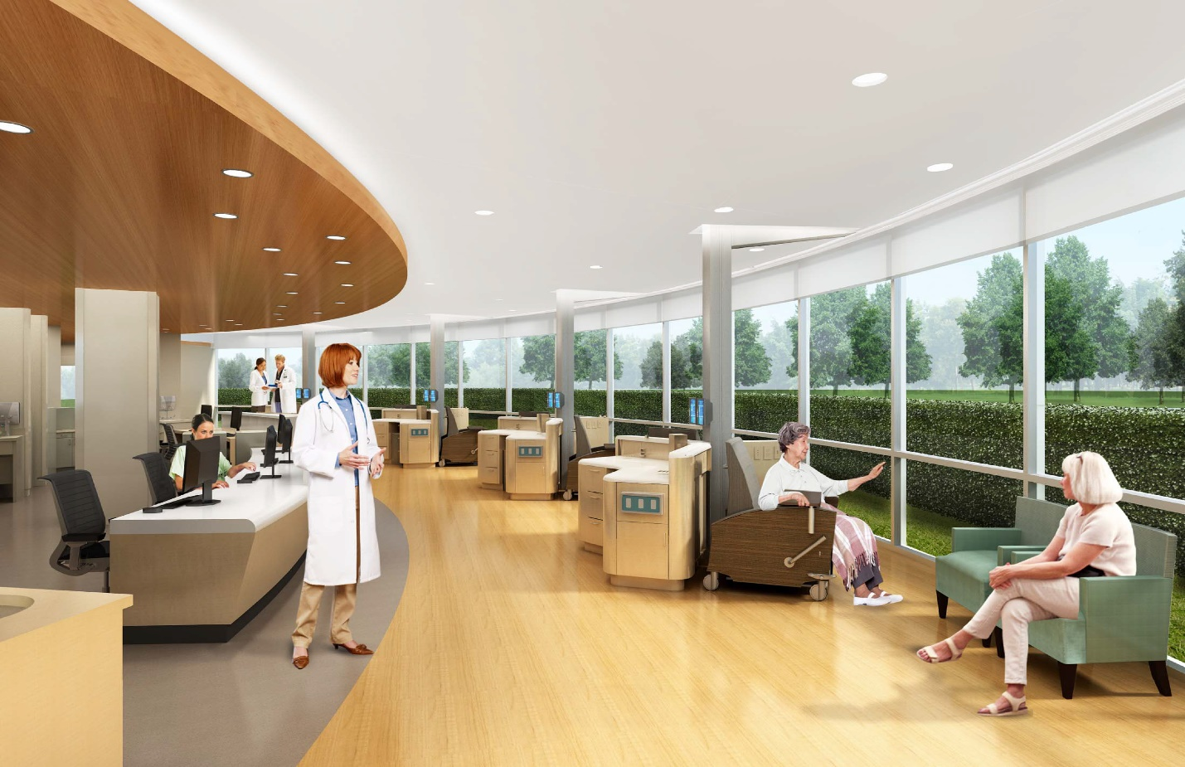

Renee Fiala 2014-2015: A Guide to Infusion Design
This project is designed to serve as a guide to inform infusion design for cancer centers. As a Master of Architecture Student at Texas A&M University, I focused my final study on Reducing Stress in Cancer Care Design. Often intimidated by the overwhelming insecurity of healthcare, I chose cancer treatment in an attempt to improve the experience of an extremely insecure population. My interest in cancer center design thrived as I had the privilege of planning two new cancer centers once I began my fellowship.
This project has been an opportunity to build on my previous research and establish some guiding principles for infusion design. As cancer treatment continues to provide hope for those affected, the design of treatment facilities will continue to be prevalent around the world. My Tradewell Project is broken into three major sections: research, case studies, and conclusions. I have built upon my research from my final study at Texas A&M and analyzed the 2 designs I had the privilege of working on as well as 4 case studies. The project concludes with major take-aways from the case studies.

